Project Design Phase-II
Data Flow Diagram & User Stories

Date | 06 October 2026
Team ID
Project Name | Script-Controlled ACL – Restrict Record Access Based on Field Value
Maximum Marks | 4 Marks

Data Flow Diagrams:
A Data Flow Diagram (DFD) is a traditional visual representation of the information flows within a system. A neat and clear DFD can depict the right amount of the system requirement graphically. It shows how data enters and leaves the system, what changes the information, and where data is stored.
Example: DFD Level 0 (Industry Standard)
Example: (Simplified)



User Stories
Use the below template to list all the user stories for the product.
User Type | Functional Requirement (Epic) | User Story Number | User Story / Task | Acceptance criteria | Priority | Release
ServiceNow User | Access Control (Epic) | USN-1 | As a user with bb1, I can view only EEE branch Institution Details records. | EEE records are visible and non-EEE records are not visible. | High | Sprint-1
ServiceNow User | Record Creation | USN-2 | As a user with bb2, I can create an Institution Details record. | The New action is available and a new record can be created. | High | Sprint-1
ServiceNow User | Record Update | USN-3 | As a user with bb3, I can edit permitted Institution Details records. | An allowed record can be opened and updated. | High | Sprint-2
ServiceNow User | Record Deletion | USN-4 | As a user with bb4, I can delete permitted Institution Details records. | An allowed record can be deleted. | High | Sprint-2
Administrator | Administrative Access | USN-5 | As an administrator, I can view Institution Details records regardless of branch. | All branch records are visible to the administrator. | High | Sprint-1
ServiceNow Administrator | Security Validation | USN-6 | As a ServiceNow administrator, I can test ACL behavior by impersonating users with different roles. | Each impersonated user receives only the permissions configured for their roles. | High | Sprint-2
ServiceNow User | Unauthorized Access | USN-7 | As a user without the required ACL role, I cannot access protected Institution Details records. | The protected operation is denied. | High | Sprint-2

Project 5 – Data Flow Diagram
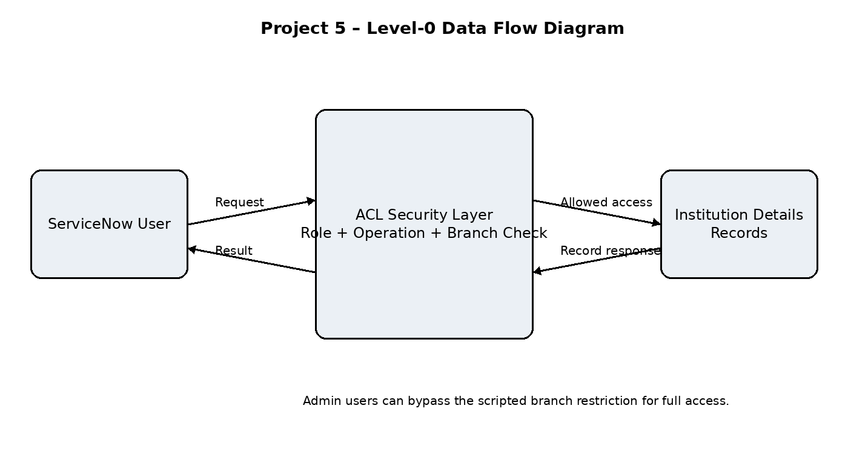
The DFD shows a ServiceNow user sending an access request to the ACL security layer. The ACL evaluates the user's role, requested operation and, for READ access, the Branch field. Permitted requests reach Institution Details records and the result is returned to the user.

